

**STUDENT PROJECT MANAGEMENT**

**Requirement & Design Specification**

– Hanoi, May 2024 –

# Record of Changes

| **Version** | **Date** | **A* M, D** | **In charge** | **Change Description** |
| --- | --- | --- | --- | --- |
| V0.1 | 13/5 | A | HaiVM | Add Actors & Use Case Diagram for Overview/User Requirements |
| V0.1 | 13/5 | A | QuynhNTN | Add Screens Flow of Overall Functionalities for Overview |
| V0.1 | 13/5 | A | ThoaPTK | Add Database Schema of Database Design/System High Level Design |
| V0.1 | 13/5 | A | HieuTL | Add Use Case Descriptions for Overview/User Requirements |
| v0.2 | 13/5 | A | HaiVM | Add Code packages for Overview/System High Level Design |

*A - Added M - Modified D - Deleted

# I. Overview

## 1. User Requirements

### 1.1 Actors

| **#** | **Actor** | **Description** |
| --- | --- | --- |
| 1 | Guest | Non-registered visitor. |
| 2 | Registered User | Visitor with an active account, having logged in. |
| 3 | Staff | User granted permission. |
| 4 | Admin | A person responsible for managing assigned projects. |

### 1.2 Use Cases

#### *a. Diagram(s)*

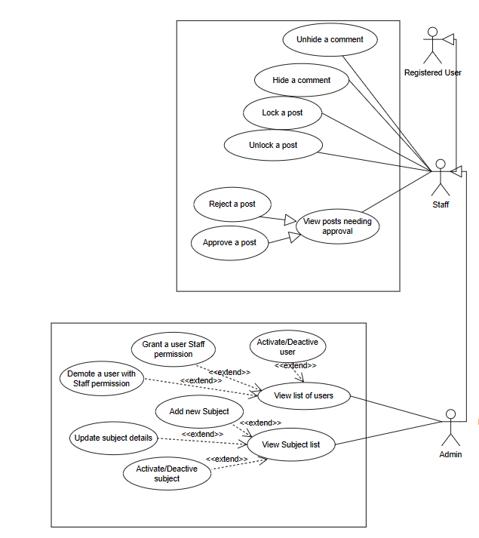

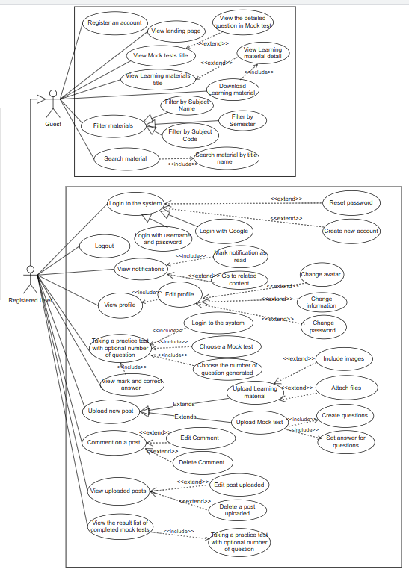

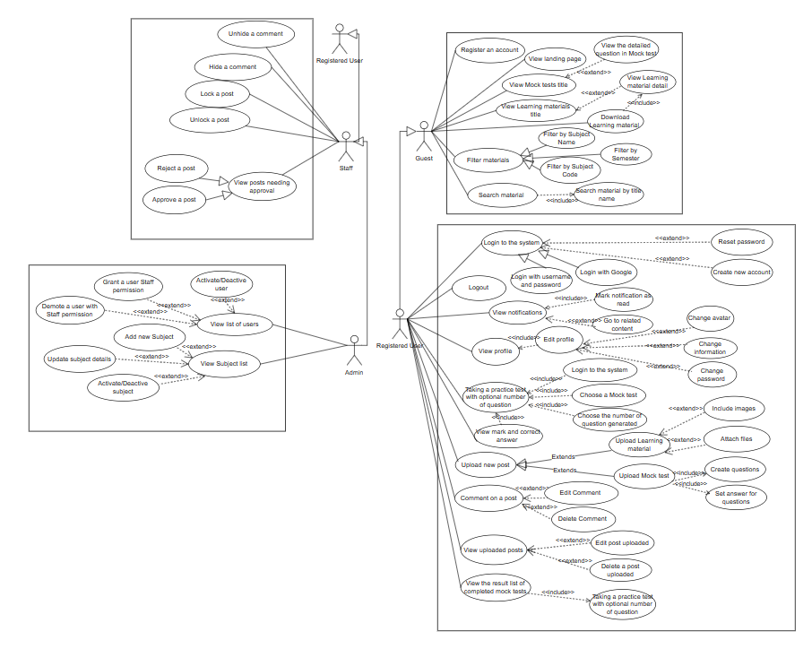

#### *b. Descriptions*

| **#** | **Feature** | **Use case** | **Use case description** |  |
| --- | --- | --- | --- | --- |
| 1 | Common | Register an account | New users can register for an account by providing required information, such as username, password, email, and personal details. Verify mail/phone | Dũng |
| 2 | Common | View page landing | Users can access the landing page of the application, providing an initial view and introduction to the system. | Hải |
| 3 | Common | View Mock Test list | Users can view the lists of Mock Test | Thoa |
| 4 | Common | View Learning material list | Users can view the lists of Learning material, the detail of Learning material | Quỳnh |
| 5 | Common | View the visiting number of Learning material | User can view the visiting number of Learning material | Quỳnh |
| 6 | Common | View the attempts of a quiz | Users can view the number of time people do the quiz | Thoa |
| 7 | Common | View the detailed question in Mock Test | Users can view the questions in the question bank of Mock Test | Thoa |
| 8 | Common | Download Learning material | Users can decide to download the Learning material | Quỳnh |
| 9 | Common | Search material | Users can locate the material they wish to reference by searching using its subject name, code or semester. | Hiếu |
| 10 | Common | Filter by Subject name | The results of searching will be filtered by the name of the subject | Hải |
| 11 | Common | Filter by Subject code | The results of searching will be filtered by the code of the subject | Hải |
| 12 | Common | Filter by Subject Semester | The results of searching will be filtered by the semester of the subject | Hải |
| 13 | Register User | Login to the system | Users can log in to the system by providing their username and password or via Google login page, as long as the input email's domain is listed in the predefined domain list | Dũng |
| 14 | Register User | Reset password | Users can reset their password in case they forget their password | Dũng |
| 15 | Register User | Logout | User can logs out of the system | Dũng |
| 16 | Register User | View/Edit profile | Users have the ability to access their personal user profiles within the system, enabling them to both view and modify their personal information, settings. | Hiếu |
| 17 | Register User | Change avatar | Users can change their account’s avatar when they choose to edit their profile | Hiếu |
| 18 | Register User | Change password | Users can change their account’s password when they choose to edit their profile | Dũng |
| 19 | Register User | View notification list | Users can view all of their notification | Hiếu |
| 20 | Register User | Mark as read notification | After users read their new notifications, these will be marked as read | Hiếu |
| 21 | Register User | Go to related content | When users click on their notification, they can view the related content of the notification | Hiếu |
| 22 | Register User | Taking Mock Test | Users can take a Mock Test and choose the number of questions | Thoa |
| 23 | Register User | View the result of the test | Users can see the result after finishing the test | Thoa |
| 24 | Register User | View list of uploaded post | Users can view the list of all posts that they uploaded | Quỳnh |
| 25 | Register User | Upload new post | Users can upload their post such as Learning material or Mock Test | Hải |
| 26 | Register User | Upload Learning material | Users can upload Learning material with images and attach files | Quỳnh |
| 27 | Register User | View list of upload post | Users can view all of their upload posts and they can update, delete their post or uploading new post | Hải |
| 28 | Register User | Edit post | Users can edit their post such as changing the information of the post | Dũng |
| 29 | Register User | Delete post | Users can delete their own post | Hiếu |
| 30 | Register User | Comment on a post | Users can comment on the posts of others or themselves | Hải |
| 31 | Register User | Edit comment | Users can edit their own comments on every posts | Hải |
| 32 | Register User | Delete comment | Users can delete their own comments on every posts | Dũng |
| 33 | Register User | View the result list of completed Mock Test | Users can view the list where store all of the results of previous Mock Test | Quỳnh |
| 34 | Staff | Hide a comment | Hide the comment which is not relevant to the community | Quỳnh |
| 35 | Staff | Unhide a comment | Staff can unhide the comment if the comment was hidden mistakenly | Thoa |
| 36 | Staff | Lock a post | Staff can lock a post when there are violations of community guidelines, or the topic becomes overly contentious,.. | Thoa |
| 37 | Staff | Unlock a post | Staff can unlock a post to allow further discussion, address updated information, or rectify previous moderation decisions,.. | Hiếu |
| 38 | Staff | View list of pending post | Staff can view all of the posts that are waiting to be pended | Hải |
| 39 | Staff | Approve a post | Staff can approve a post if it is relevant to public | Dũng |
| 40 | Staff | Reject a post | Staff can reject a post if it is not suitable for community | Hải |
| 41 | Admin | View list of users | Admin can view the list of all users | Quỳnh |
| 42 | Admin | Activate/Deactivate user | Admin can ban or unban any user of the system | Dũng |
| 43 | Admin | Grant a user Staff permission | Admin can choose who will be a staff and grant the permission for this user | Dũng |
| 44 | Admin | Demote a user with Staff permission | Admin can demote a staff to be a normal user | Dũng |
| 45 | Admin | Manage Subject | Admin can manage all the subject in the system | Hiếu |
| 46 | Admin | Add new Subject | Admin can add new subject into the system | Hiếu |
| 47 | Admin | View subject list | Admin can see the list of all subject i | Hiếu |
| 48 | Admin | Update subject details | Admin can update, insert new information of a subject | Hải |
| 49 | Admin | Activate/Deactivate subject | Admin has the right to activate or deactivate any subject | Hải |

#### 2. Overall Functionalities

### 2.1 Screens Flow

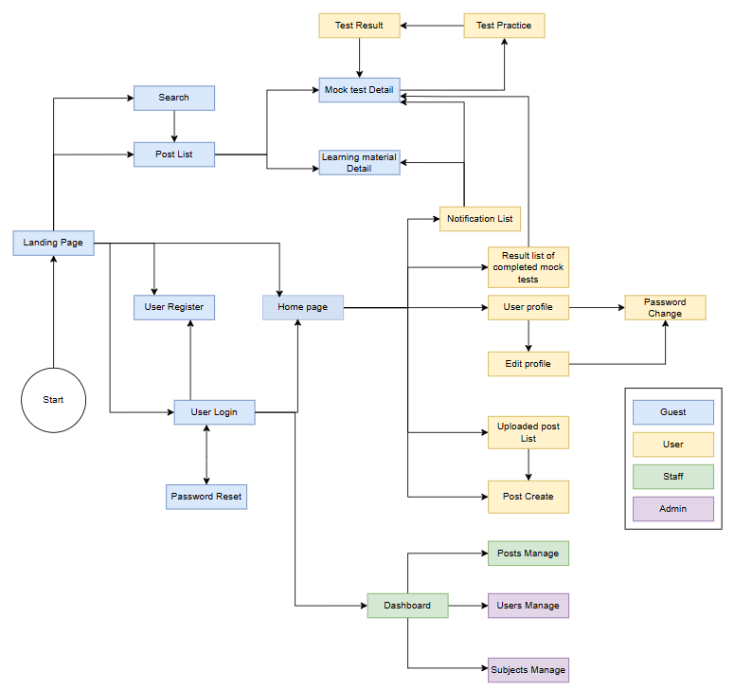

### 2.2 Screens Description

| **STT** | **Screen/Function** | **Screen/Function Details** |
| --- | --- | --- |
| 1 | Landing Page | Initial page that users see when they visit the website, provides an overview, introduction, navigation options to guide users to relevant sections of the website. |
| 2 | User Register | Create a new account by providing necessary information such as username, email, password. It is the registration process for new users to gain access to the application. |
| 3 | User Login | Enables users who already have an account to log in to the application. Users enter their registered email or phone number and password to authenticate and access their account. |
| 4 | Password Reset | Reset password via Email or Phone Number |
| 5 | Post List | View all post |
| 6 | Search | Enter keywords to find relevant posts based on their search criteria. |
| 7 | Mock test Detail | Detailed information about a mock test include questions and answers |
| 8 | Learning material Detail | Detailed information about a specific learning material or educational resource include text, images, videos, or other multimedia content to help users learn and understand a particular subject or topic. |
| 9 | Home page | Acts as the central hub of the website, provides users with a concise overview and easy access to key features, personalized content, notifications |
| 10 | Notification List | Show a list of notifications for the use include updates, reminders, messages, or any other relevant information that requires the user's attention. |
| 11 | Test Practice | Offer practice questions to help users evaluate their knowledge and prepare for actual tests or assessments. |
| 12 | Test Result | Score achieved by the user after completing a test or assessment includes number of correct answers, percentage score, and any additional analysis. |
| 13 | Result list of completed mock tests | List of completed mock tests with their corresponding results. |
| 14 | User profile | Show information about user include the username, profile picture and other relevant data. |
| 15 | Edit profile | Allows users to modify or update their profile information such as their name, profile picture and other relevant data to keep their profiles up to date. |
| 16 | Uploaded post List | List of posts created by the user. |
| 17 | Post Create | Enables users to create and publish new posts |
| 18 | Password Change | Allows the user to change password to a new one |
| 19 | Dashboard | Comprehensive overview of relevant information, statistics, or activities within the website to present data and help users monitor and analyze specific metrics or performance indicators. |
| 20 | Posts Manage | Allows users with appropriate permissions to manage posts such as deleting, approving,... |
| 21 | Users Manage | Allows users with appropriate permissions to manage user-related activities within the application. It may include features to view, search, edit, suspend, or delete user accounts,assign roles or permissions to users, and perform other user management tasks. |
| 22 | Subjects Manage | Allows users with appropriate permissions to view, create, edit, or delete subjects |

### 2.3 Screen Authorization

| **#** | **Screen** | **Guest** | **User** | **Staff** | **Admin** |
| --- | --- | --- | --- | --- | --- |
| 1 | Landing Page | X | X | X | X |
| 2 | User Register | X | X | X | X |
| 3 | User Login | X | X | X | X |
| 4 | Password Reset | X | X | X | X |
| 5 | Post List | X | X | X | X |
| 6 | Search | X | X | X | X |
| 7 | Mock test Detail | X | X | X | X |
| 8 | Learning material Detail | X | X | X | X |
| 9 | Home page |  | X | X | X |
| 10 | Notification List |  | X | X | X |
| 11 | Test Practice |  | X | X | X |
| 12 | Test Result |  | X | X | X |
| 13 | Result list of completed mock tests |  | X | X | X |
| 14 | User profile |  | X | X | X |
| 15 | Edit profile |  | X | X | X |
| 16 | Uploaded post List |  | X | X | X |
| 17 | Post Create |  | X | X | X |
| 18 | Password Change |  | X | X | X |
| 19 | Dashboard |  |  | X | X |
| 20 | Posts Manage |  |  | X | X |
| 21 | Users Manage |  |  |  | X |
| 22 | Subjects Manage |  |  |  | X |

### 2.4 Non-UI Functions

| **#** | **Feature** | **System Function** | **Description** |
| --- | --- | --- | --- |
| 1 | Common | Authorization | System check permission of user when they use an authorized function. |
| 2 | Common | Hash password | Passwords must be encrypted before adding to database to secure user information |
| 3 |  |  |  |
| 4 |  |  |  |

## 3. System High Level Design

### 3.1 Database Design

#### *a. Database Schema*

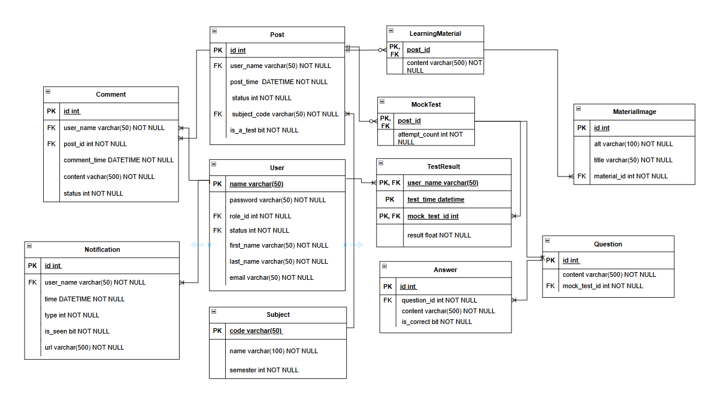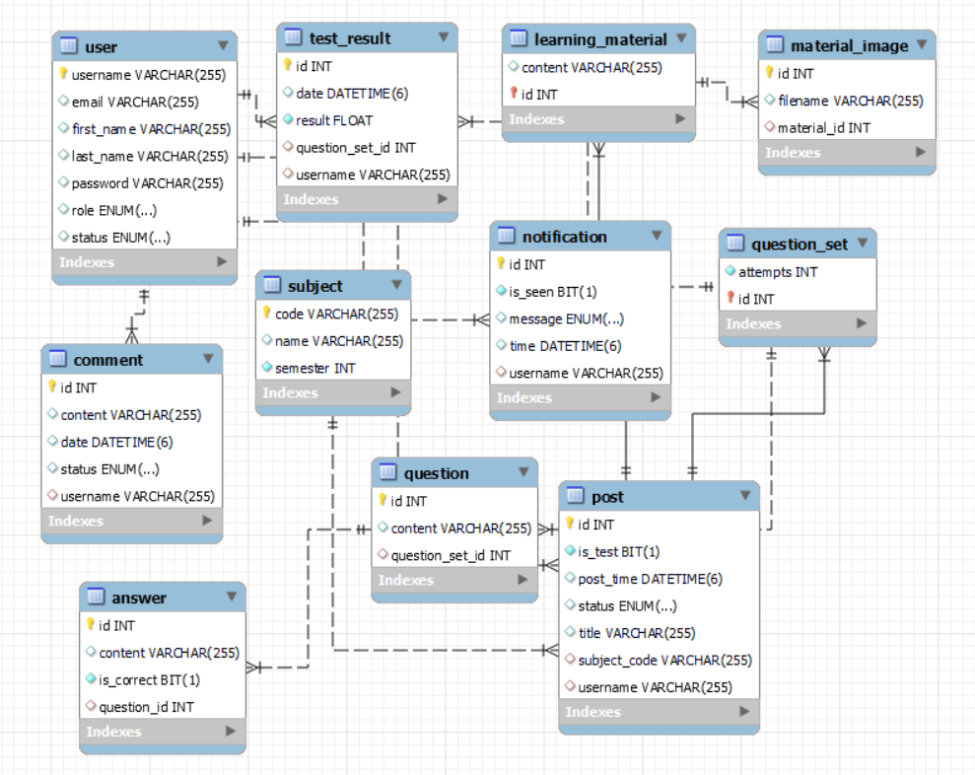

#### *b. Table Descriptions*

#### 

| **No** | **Table** | **Description** |
| --- | --- | --- |
| 01 | Users | To store user's account information  - Primary keys: name  - Foreign keys: role_id , status  - Unique keys: email  - Constraint :  +> name: Only contain digits or characters  +> password: from 6 to 50 characters  +> role_id : default value = 1  +> status : default value = 1 |
| 02 | AccountStatus | To store the status of an account (active or deactivated)  - Primary keys: id |
| 03 | Roles | To store the roles of an account (admin , staff and user)  - Primary keys: id |
| 04 | Comments | To store information about the comments of an account  - Primary keys: id  - Foreign keys:  user_name, post_id , status  - Constraint :  +> comment_time: valid datetime |
| 05 | Notification | To store the notifications of an account  - Primary keys: id  - Foreign keys: user_name , type  - Constraint:  +> comment_time: valid datetime |
| 06 | NotificationType | To store specific type of a notification  - Primary keys: id  - Constraint:  +> comment_time: valid datetime |
| 07 | TestResult | To store the result of tests  - Primary keys: user_name, test_time, mock_test_id  - Foreign keys: user_name, test_time, mock_test_id  - Constraint:  +> comment_time: valid datetime |
| 08 | Posts | To store information about the posts  - Primary keys: id  - Foreign keys: user_name, status, subject_code  - Constraint:  +> comment_time: valid datetime |
| 09 | Status | To store status detail  - Primary keys: id  - Constraint :  +> comment_time: valid datetime |
| 10 | Subjects | To store images contained in a learning material post  - Primary key: code  - Constraint :  +> comment_time: valid datetime |
| 11 | MaterialImages | To store images contained in a learning material post  - Primary key: id  - Foreign key: material_id  - Constraint :  +> comment_time: valid datetime |
| 12 | MockTests | Child table of a post  - Primary key: post_id  - Foreign key: post_id  - Constraint :  +> comment_time: valid datetime |
| 13 | Questions | To store content of a mock test post  - Primary key: id  - Foreign key: mock_test_id  - Constraint :  +> comment_time: valid datetime |
| 14 | Answers | To store answer options of a mock test question  - Primary key: id  - Foreign key: question_id  - Constraint :  +> comment_time: valid datetime |
| 15 | LearningMaterials | Child table of a post. To store detailed content of a learning material post  - Primary key: post_id  - Foreign key: post_id |

### 3.2 Code Packages

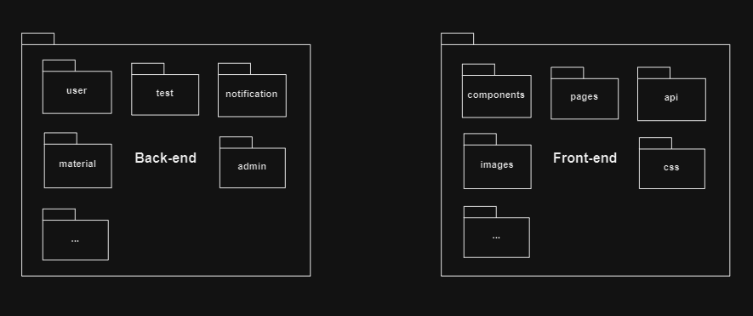

***Package descriptions***

| **No** | **Package** | **Description** |
| --- | --- | --- |
| 1 | user | Contains User-feature-related classes (object model, DAO, controller,…)  **Classes’ names: UserDAO, UserController,...** |
| 2 | test | Contains Test-feature-related classes (object model, DAO, controller,…) |
| 3 | material | Contains Learning-material-feature-related classes (object model, DAO, controller,…) |
| 4 | notification | Contains Notification-feature-related classes (object model, DAO, controller,…) |
| 5 | admin | Contains Admin-feature-related classes (DAO, controller,…) |
| 6 | config | Components define system configurations.  **Classes’ names: ConfigName** |
| 7 | components | Contains UI components (header, footer, sidebar,…) |
| 8 | pages | Contains web pages components |
| 9 | api | Contains api-related components |
| 10 | images | Contains avatar and learning material images |
| 11 | css | Contains css files |